# Basic Sketching Techniques

Sketching is an essential skill for interior designers, allowing them to quickly express ideas, visualise space, and communicate concepts with clients and collaborators. Developing a good sketching technique will enable designers to quickly represent spatial arrangements, furniture placement, lighting, and material finishes.

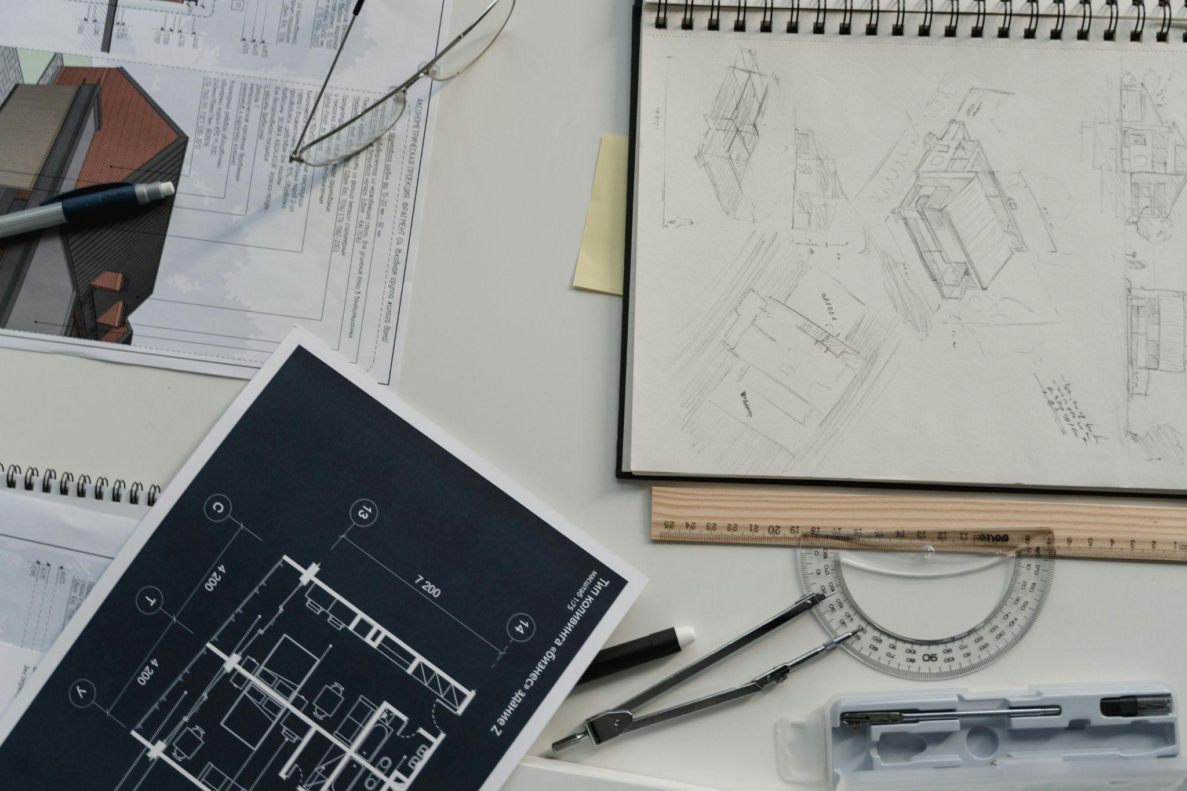

Fig 1. Unsplash (n.d.) Technical drawings

## Line Quality, Control and Proportion

Lines are the building blocks of any drawing. As an interior designer, all your visual representations will be based on lines - straight lines, curved lines, diagonal lines, etc. To clearly record your designs, whether you are still in the ideation phase or delivering a final presentation to a client, you need to be able to use lines and line weights effectively. Useful skills in controlling your lines when drawing, include being able to draw:

* straight lines to create sketches of walls, furniture, and architectural details
* smooth, flowing curved lines to create furniture, plants, soft furnishings, decor, etc.

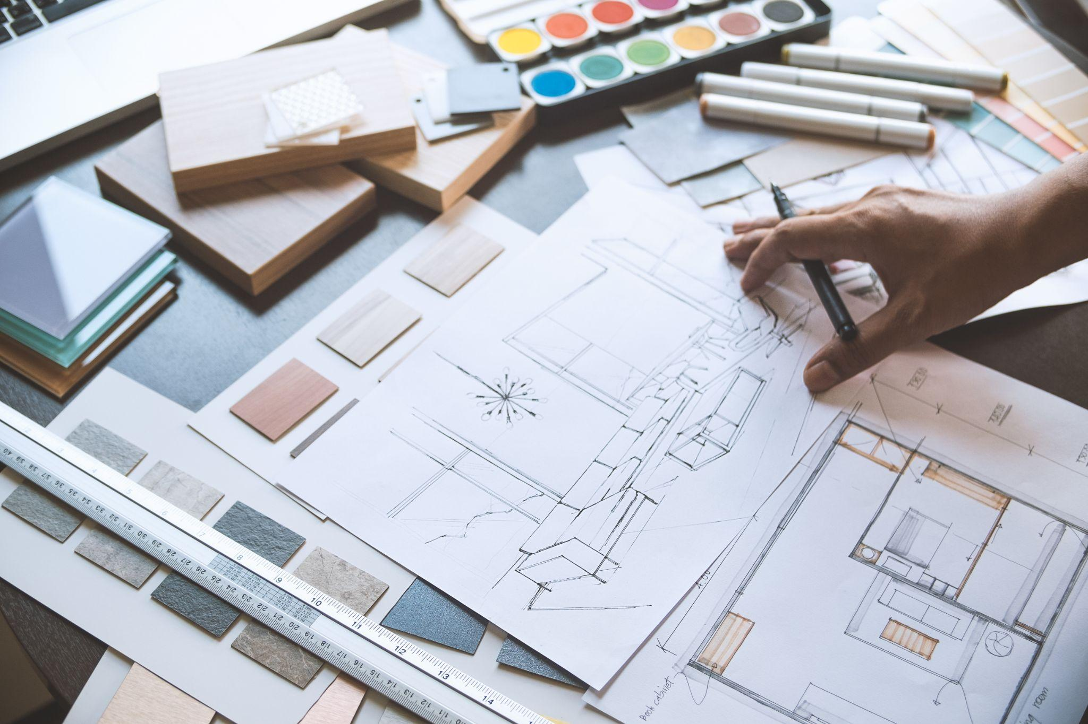

Fig 2. Technical drawings

Line weight refers to the varying thickness of your lines and can add depth and dimension to technical sketches, like floor plans and elevations. Thicker lines can represent major elements like walls or furniture, while thinner lines are useful for fine details. Line weight can also help indicate distance. You can create this illusion of space by drawing objects that are ‘closer’ with heavier lines while applying thinner and lighter lines to elements toward the ‘back’. Practising consistently by doing various exercises and simply “doodling” your ideas, will help you become more confident with the way you control your lines and create them.

In 3D sketching, proportion is essential for maintaining accuracy and realism in a drawing. Proper proportion ensures that different elements of an object or scene relate correctly to one another, preventing distortions that could affect the overall composition. Implementing proportion effectively involves understanding perspective, scale, and spatial relationships, which help create depth and realism. Artists often use reference points, grids, and measurement techniques to maintain consistency. Taking proportion into account is crucial for accurately developing ideas, as it allows for a clear and precise representation of concepts, making designs more believable and visually coherent.

## Texture Representation

Texture representation can be achieved with the implementation of different techniques. These include adding “patterns” to a surface, to represent a material, or utilising colour in various ways, to show light on a surface, or depth of field. Different textures can be achieved using the following techniques:

1. **Hatching and Cross-Hatching** are techniques that are used to represent shadows and texture in sketches. Hatching (parallel lines) and cross-hatching (intersecting lines) add depth, suggest material textures like wood grain, and create shading to indicate light sources.

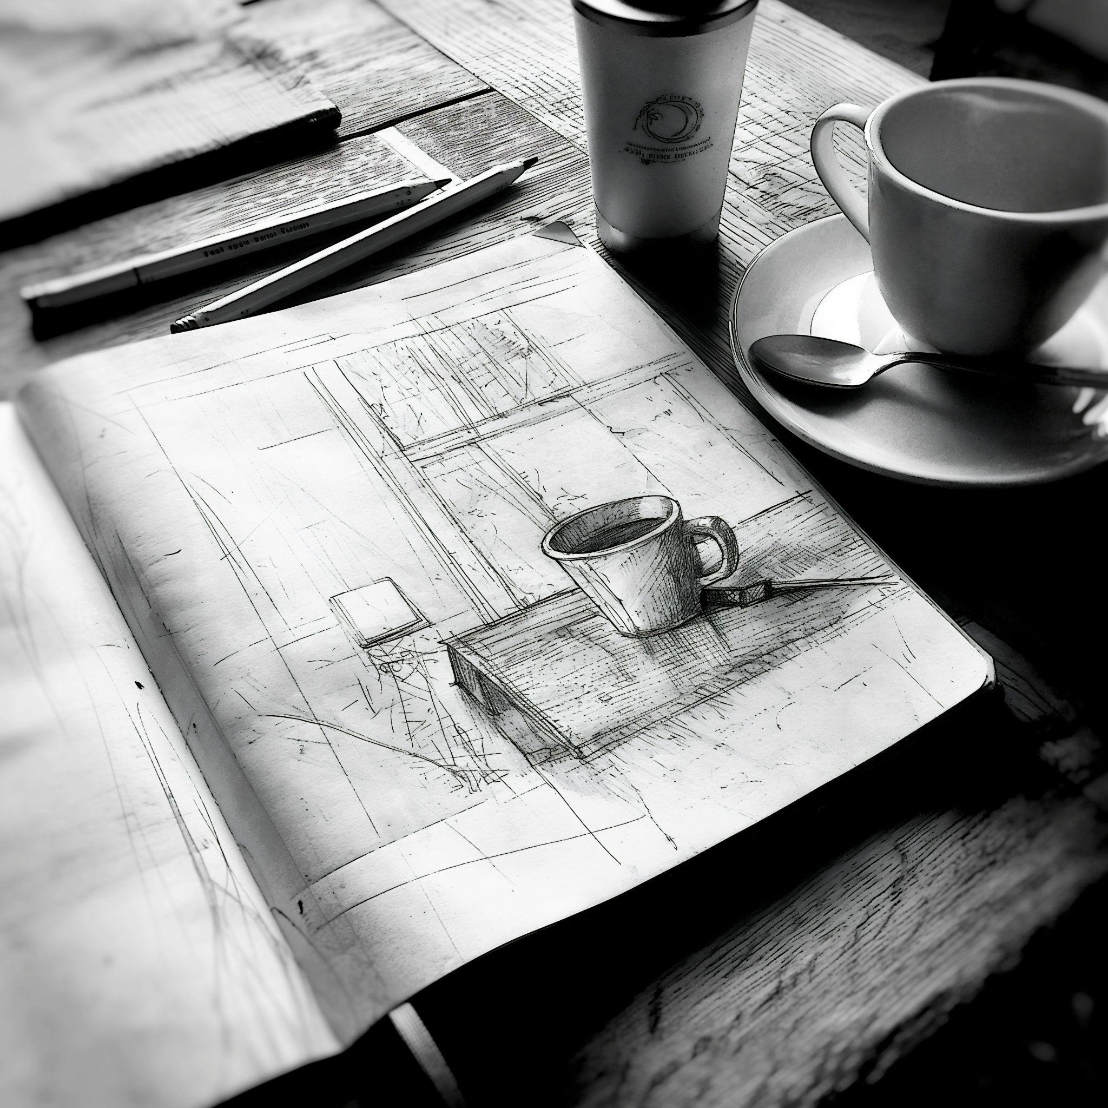

Fig 3. Unsplash (n.d.) Creating texture in a sketch

1. **Stippling** involves using small dots to represent texture or shading. Stippling can be effective for representing rough surfaces like stone or concrete. To create shadows, enhance depth, and highlight light sources, you will need to apply shading techniques to your drawing. For instance, shading under furniture or against walls gives the sketch a three-dimensional look.

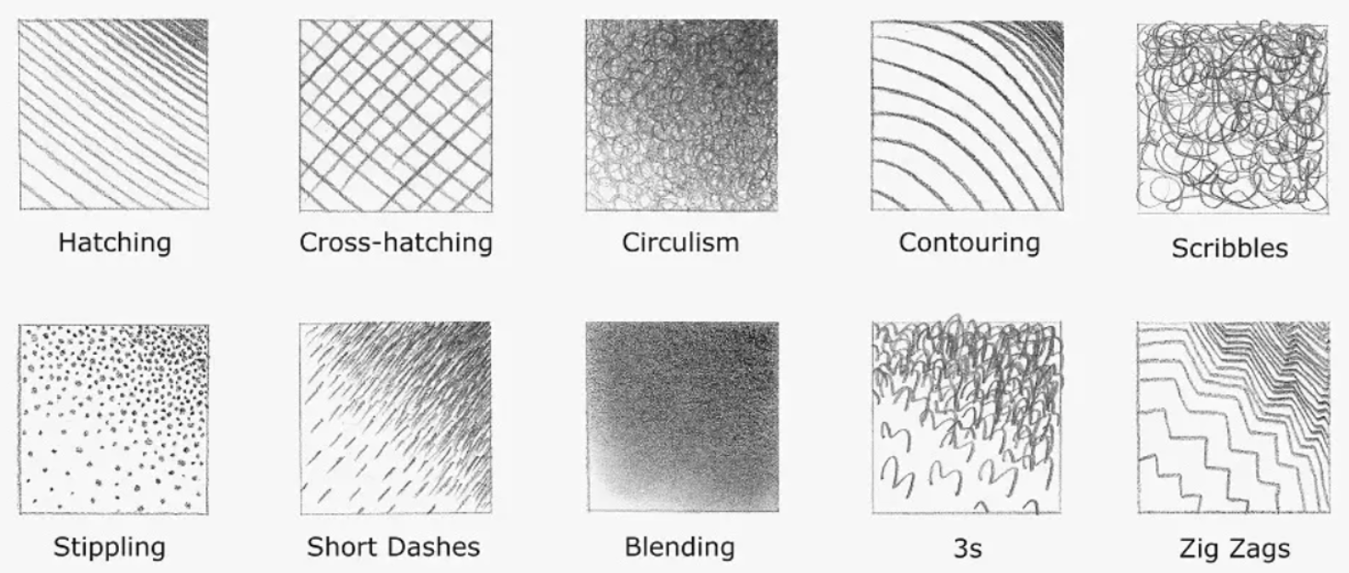

Fig 4. Canva (n.d.) Texture technique

## 

1. **Creating Depth:** One way to add more depth to your visuals and represent the play of light on an object, is to add shadows to your sketch. To do this, you need to use softer lines or blending techniques. Pencils or markers can create smooth, realistic shadows. Shaded areas are not possible without a light source (natural or artificial), so always consider where the light in a space is coming from—whether sunlight from windows or light from fixtures. This helps show how shadows fall across furniture and walls, creating a more dynamic sketch.

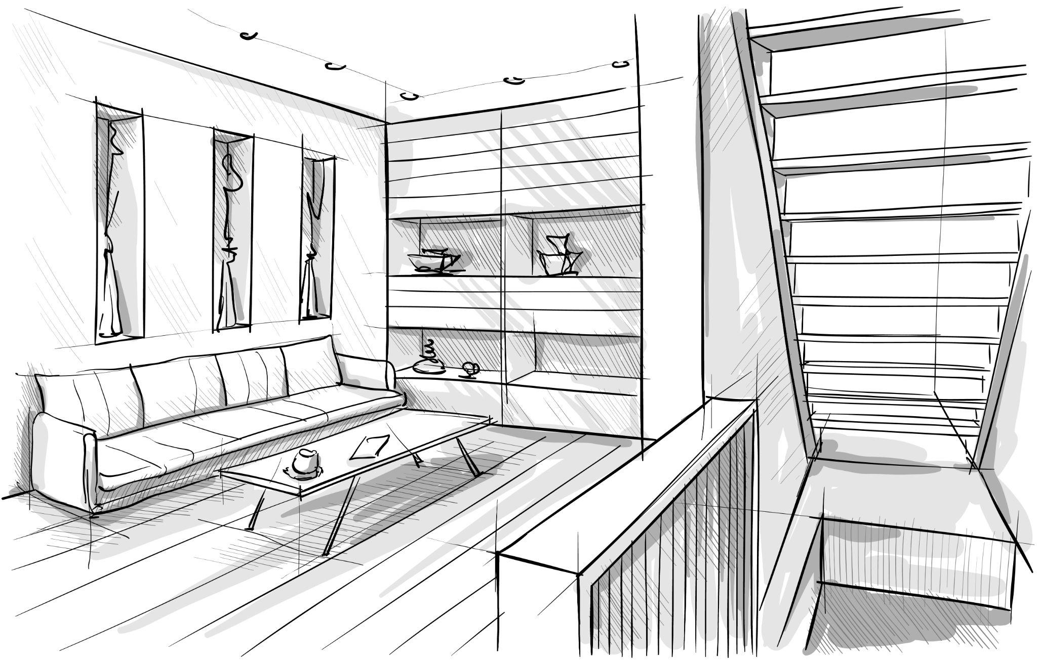

Fig 5. Digital sketch with shading applied to certain areas

Another way to create depth is to overlap objects in a sketch. Overlapping and layering refer to placing objects in the foreground, middle ground, and background of a sketch, e.g. showing a chair in front of a table. This illusion adds 3D depth to the drawing, making it more dynamic and realistic to create a sense of space and hierarchy within the design.

## 3. Rendering Materials and Finishes

Once you have developed your basic sketching skills, it’s time to advance to colour rendering. Rendering means to add basic colours to your design sketches using coloured pencils, markers, pastels or watercolours to represent different finishes and materials. Colours are an important element because they help to convey the mood of a space and give clients a better idea of how it will look in reality.

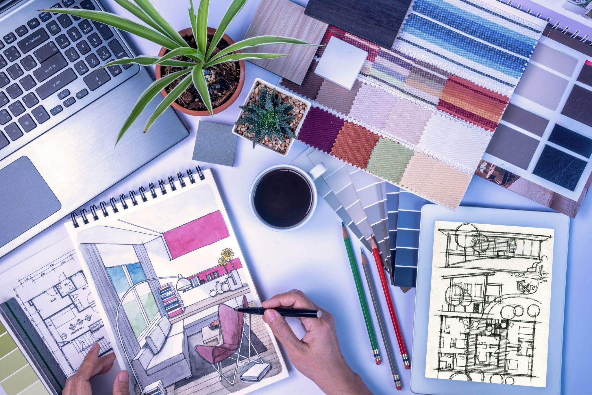

Fig 6. Digital sketch with shading applied to certain areas

As an interior designer, you will also need to depict different soft and hard material textures, such as wood, stone, fabric, or glass, in your visuals. Use techniques like stippling for rough textures, feathering for fabric, or hatching for wood grain, to differentiate between materials in sketches.

## Perspective Drawing

Combining the techniques mentioned above, will allow you to advance to more technical drawings, like 3D perspective drawings. Perspective drawing is a way of representing a space in a three dimensional way, which shows the width and the depth of the said space (3D). We categorised Perspective drawing into one-point, two-point and three-point perspective drawings, depending on the amount of vanishing points we choose to implement. As an Interior Designer, presenting a 3D visual to our client will make the process of understanding our vision much easier and will also contribute in streamlining the process of presenting a Design Package.

## Digital Sketching Tools

With the advancement of technologies, many Interior Designers now choose to work digitally in order to produce their 3D visuals, as this takes less time and produces some outstanding effects and results. Many interior designers will use digital tools like SketchUp, Procreate, or Adobe Fresco to create 3D visuals of their designs. These tools allow for more flexibility with colour, texture, and editing capabilities.

Regardless of how much digital drawing tools advance, mastering basic, manual sketching techniques, helps interior designers communicate their ideas effectively and bring their visions to life. From line quality and perspective to shading and texture representation, these techniques form the foundation for more detailed and refined design work. Regular practise will improve the ability to quickly visualise spaces, create dynamic layouts, and develop strong compositions, all of which are critical in the field of interior design.